DR:

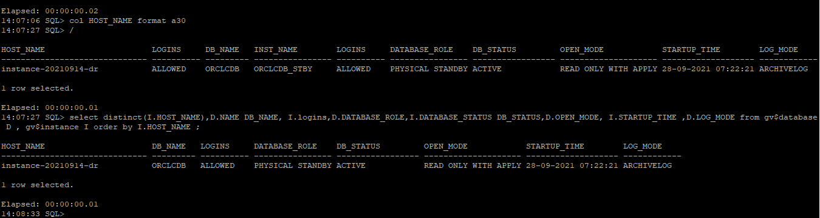

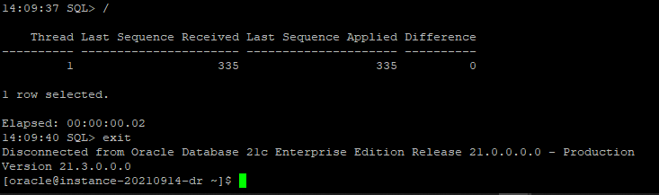

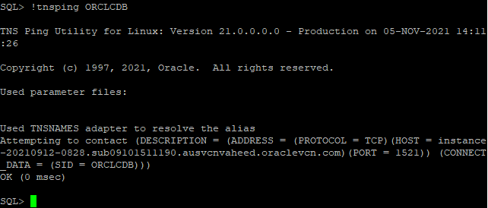

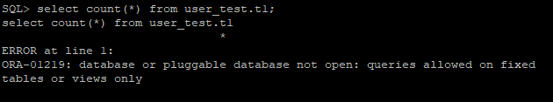

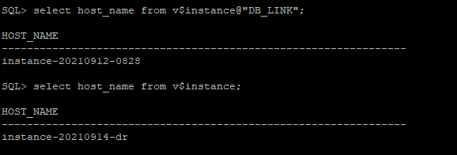

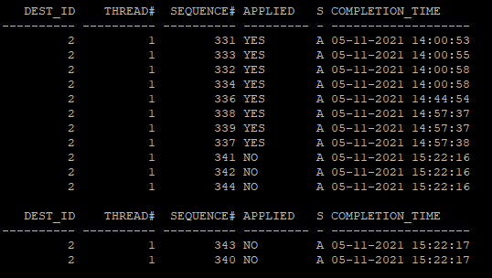

Primary:

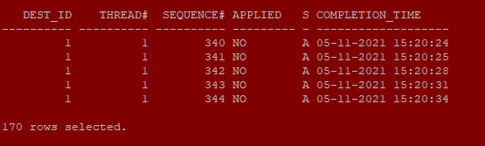

Test 1:

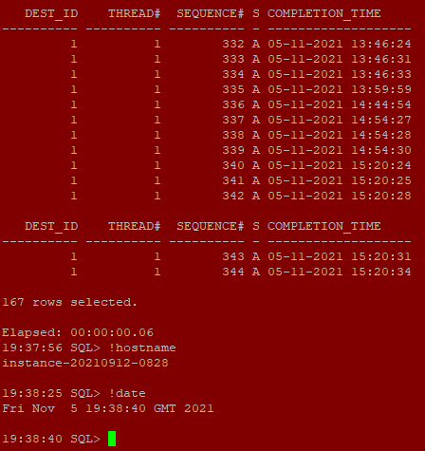

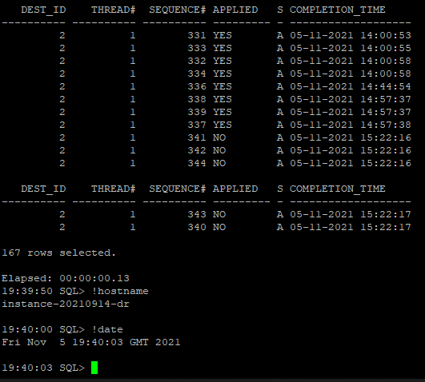

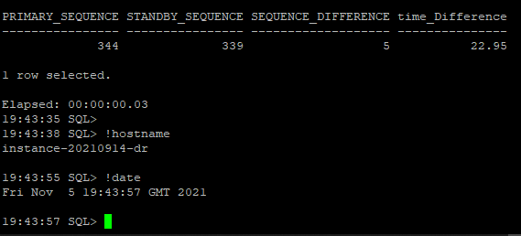

After:

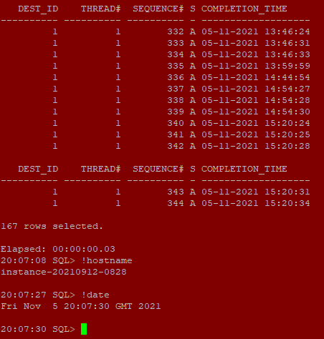

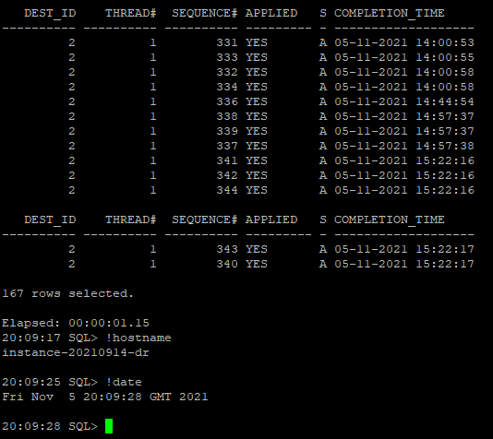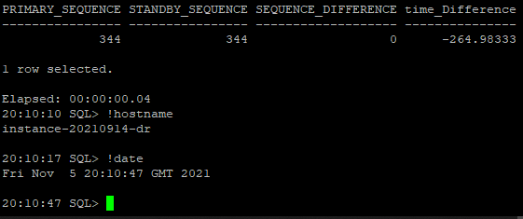

Test 2:

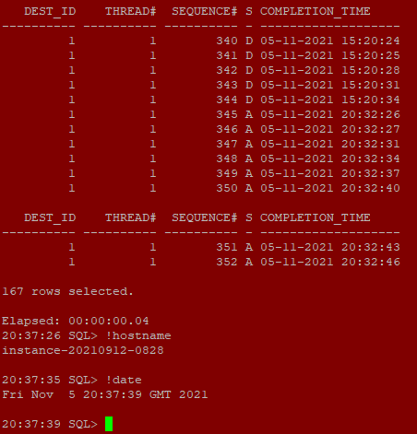

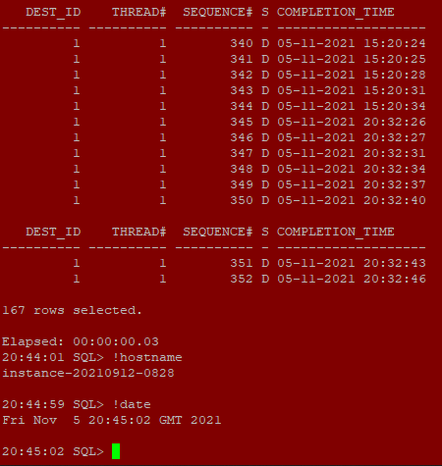

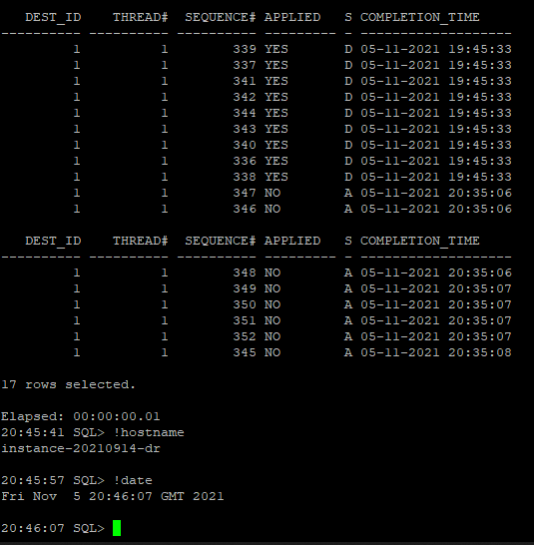

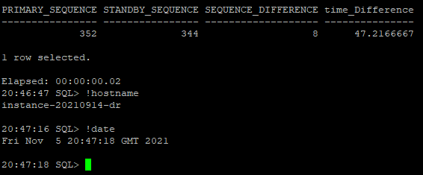

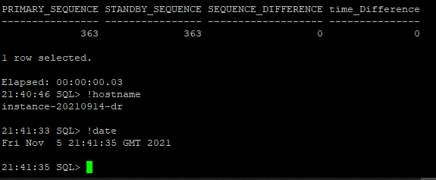

7thrun

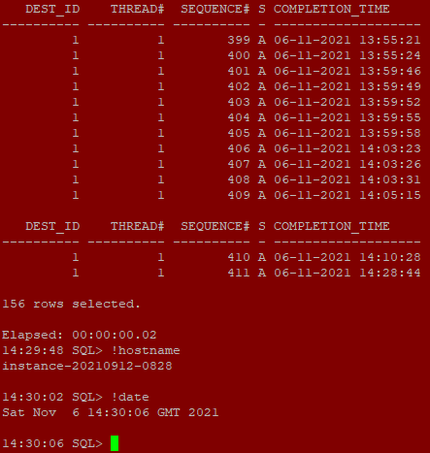

DEST_ID THREAD# SEQUENCE# S COMPLETION_TIME

---------- ---------- ---------- - -------------------

1 1 399 A 06-11-2021 13:55:21

1 1 400 A 06-11-2021 13:55:24

1 1 401 A 06-11-2021 13:59:46

1 1 402 A 06-11-2021 13:59:49

1 1 403 A 06-11-2021 13:59:52

1 1 404 A 06-11-2021 13:59:55

1 1 405 A 06-11-2021 13:59:58

1 1 406 A 06-11-2021 14:03:23

1 1 407 A 06-11-2021 14:03:26

1 1 408 A 06-11-2021 14:03:31

1 1 409 A 06-11-2021 14:05:15

DEST_ID THREAD# SEQUENCE# S COMPLETION_TIME

---------- ---------- ---------- - -------------------

1 1 410 A 06-11-2021 14:10:28

1 1 411 A 06-11-2021 14:28:44

156 rows selected.

Elapsed: 00:00:00.02

14:29:48 SQL> !hostname

instance-20210912-0828

14:30:02 SQL> !date

Sat Nov 6 14:30:06 GMT 2021

14:30:06 SQL>

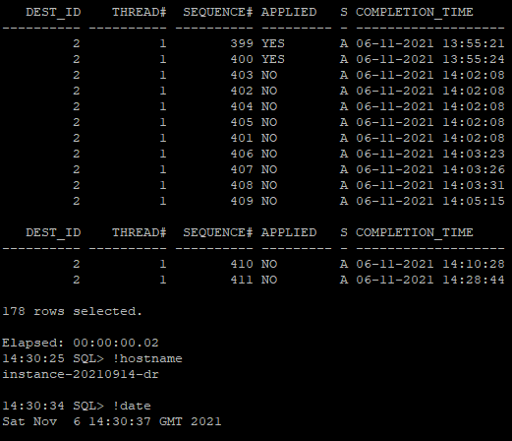

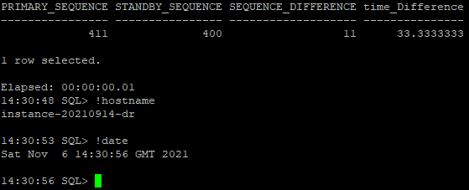

DEST_ID THREAD# SEQUENCE# APPLIED S COMPLETION_TIME

---------- ---------- ---------- --------- - -------------------

2 1 399 YES A 06-11-2021 13:55:21

2 1 400 YES A 06-11-2021 13:55:24

2 1 403 NO A 06-11-2021 14:02:08

2 1 402 NO A 06-11-2021 14:02:08

2 1 404 NO A 06-11-2021 14:02:08

2 1 405 NO A 06-11-2021 14:02:08

2 1 401 NO A 06-11-2021 14:02:08

2 1 406 NO A 06-11-2021 14:03:23

2 1 407 NO A 06-11-2021 14:03:26

2 1 408 NO A 06-11-2021 14:03:31

2 1 409 NO A 06-11-2021 14:05:15

DEST_ID THREAD# SEQUENCE# APPLIED S COMPLETION_TIME

---------- ---------- ---------- --------- - -------------------

2 1 410 NO A 06-11-2021 14:10:28

2 1 411 NO A 06-11-2021 14:28:44

178 rows selected.

Elapsed: 00:00:00.02

14:30:25 SQL> !hostname

instance-20210914-dr

14:30:34 SQL> !date

Sat Nov 6 14:30:37 GMT 2021

14:30:37 SQL> select p.SEQUENCE# "PRIMARY_SEQUENCE" , s.SEQUENCE# "STANDBY_SEQUENCE", (p.SEQUENCE# - s.SEQUENCE#) "SEQUENCE_DIFFERENCE",(p.COMPLETION_TIME - s.COMPLETION_TIME)*24*60 "time_Difference"

from

14:30:46 2 14:30:46 3 (SELECT THREAD# ,SEQUENCE#,COMPLETION_TIME FROM V$ARCHIVED_LOG@db_link WHERE DEST_ID=1 and (THREAD#,SEQUENCE# ) IN (SELECT THREAD#,MAX(SEQUENCE#) FROM V$ARCHIVED_LOG@db_link GROUP BY THREAD#)) p,

(SELECT THREAD# ,SEQUENCE#,COMPLETION_TIME FROM V$ARCHIVED_LOG WHERE (THREAD#,SEQUENCE# ) IN (SELECT THREAD#,MAX(SEQUENCE#) FROM V$ARCHIVED_LOG WHERE APPLIED='YES' GROUP BY THREAD#)) s

where p.THREAD#=s.THREAD#;14:30:46 4 14:30:46 5

PRIMARY_SEQUENCE STANDBY_SEQUENCE SEQUENCE_DIFFERENCE time_Difference

---------------- ---------------- ------------------- ---------------

411 400 11 33.3333333

1 row selected.

Elapsed: 00:00:00.01

14:30:48 SQL> !hostname

instance-20210914-dr

14:30:53 SQL> !date

Sat Nov 6 14:30:56 GMT 2021

14:30:56 SQL>

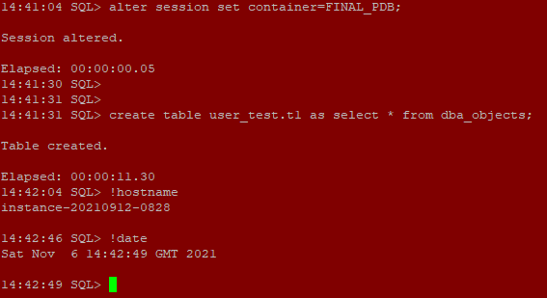

14:41:04 SQL> alter session set container=FINAL_PDB;

Session altered.

Elapsed: 00:00:00.05

14:41:30 SQL>

14:41:31 SQL>

14:41:31 SQL> create table user_test.t1 as select * from dba_objects;

Table created.

Elapsed: 00:00:11.30

14:42:04 SQL> !hostname

instance-20210912-0828

14:42:46 SQL> !date

Sat Nov 6 14:42:49 GMT 2021

14:42:49 SQL>

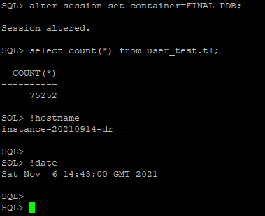

SQL> alter session set container=FINAL_PDB;

Session altered.

SQL> select count(*) from user_test.t1;

COUNT(*)

----------

75252

SQL> !hostname

instance-20210914-dr

SQL>

SQL> !date

Sat Nov 6 14:43:00 GMT 2021

SQL>



HOST_NAME LOGINS DB_NAME INST_NAME LOGINS DATABASE_ROLE DB_STATUS OPEN_MODE STARTUP_TIME LOG_MODE

------------------------------ ---------- --------- ---------------- ---------- ---------------- ----------------- -------------------- ------------------- ------------

instance-20210912-0828 ALLOWED ORCLCDB ORCLCDB ALLOWED PRIMARY ACTIVE READ WRITE 28-09-2021 03:51:39 ARCHIVELOG

1 row selected.

Elapsed: 00:00:00.01

07:56:09 SQL>

07:56:26 SQL>

07:56:26 SQL> !date

Sun Nov 7 07:56:28 GMT 2021



HOST_NAME LOGINS DB_NAME INST_NAME LOGINS DATABASE_ROLE DB_STATUS OPEN_MODE STARTUP_TIME LOG_MODE

------------------------------ ---------- --------- ---------------- ---------- ---------------- ----------------- -------------------- ------------------- ------------

instance-20210914-dr ALLOWED ORCLCDB ORCLCDB_STBY ALLOWED PHYSICAL STANDBY ACTIVE READ ONLY WITH APPLY 06-11-2021 14:36:17 ARCHIVELOG

1 row selected.

Elapsed: 00:00:00.00

07:58:44 SQL> !date

Sun Nov 7 07:59:13 GMT 2021

